**DriverPass Design Document**

Nick Allen

June 18th, 2023

## UML Diagrams:

### UML Use Case Diagram

### UML Activity Diagrams

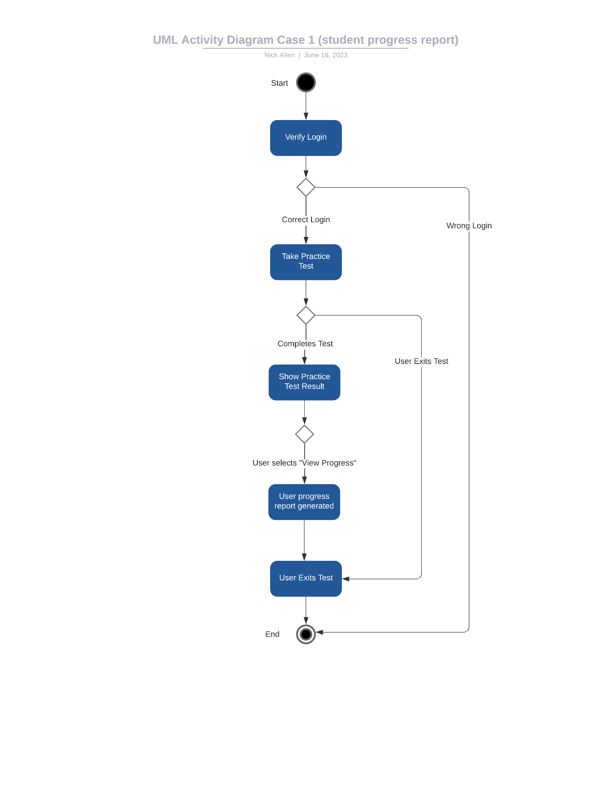

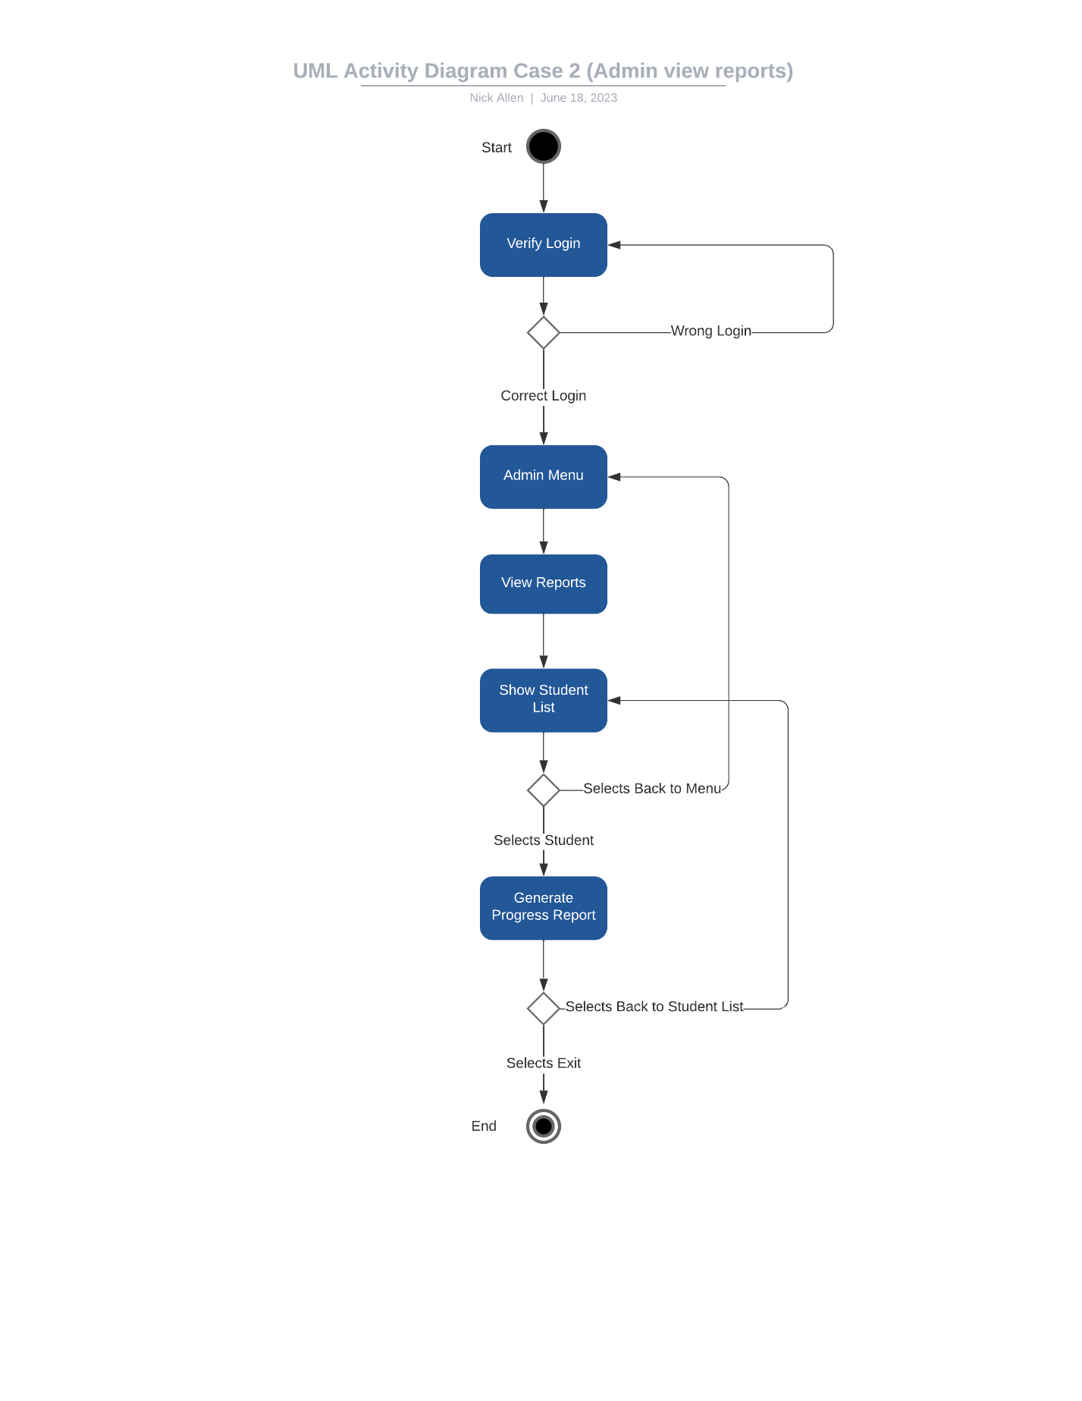

### UML Sequence Diagram

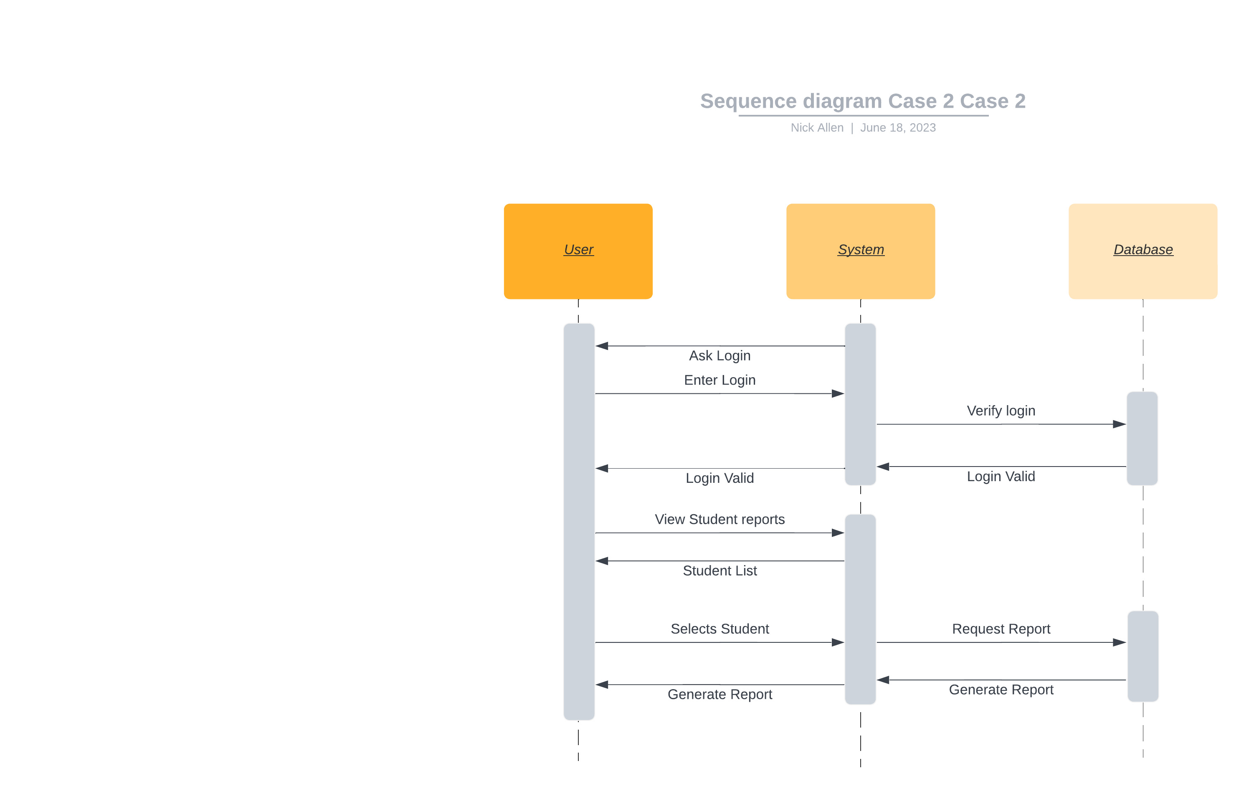

### UML Class Diagram

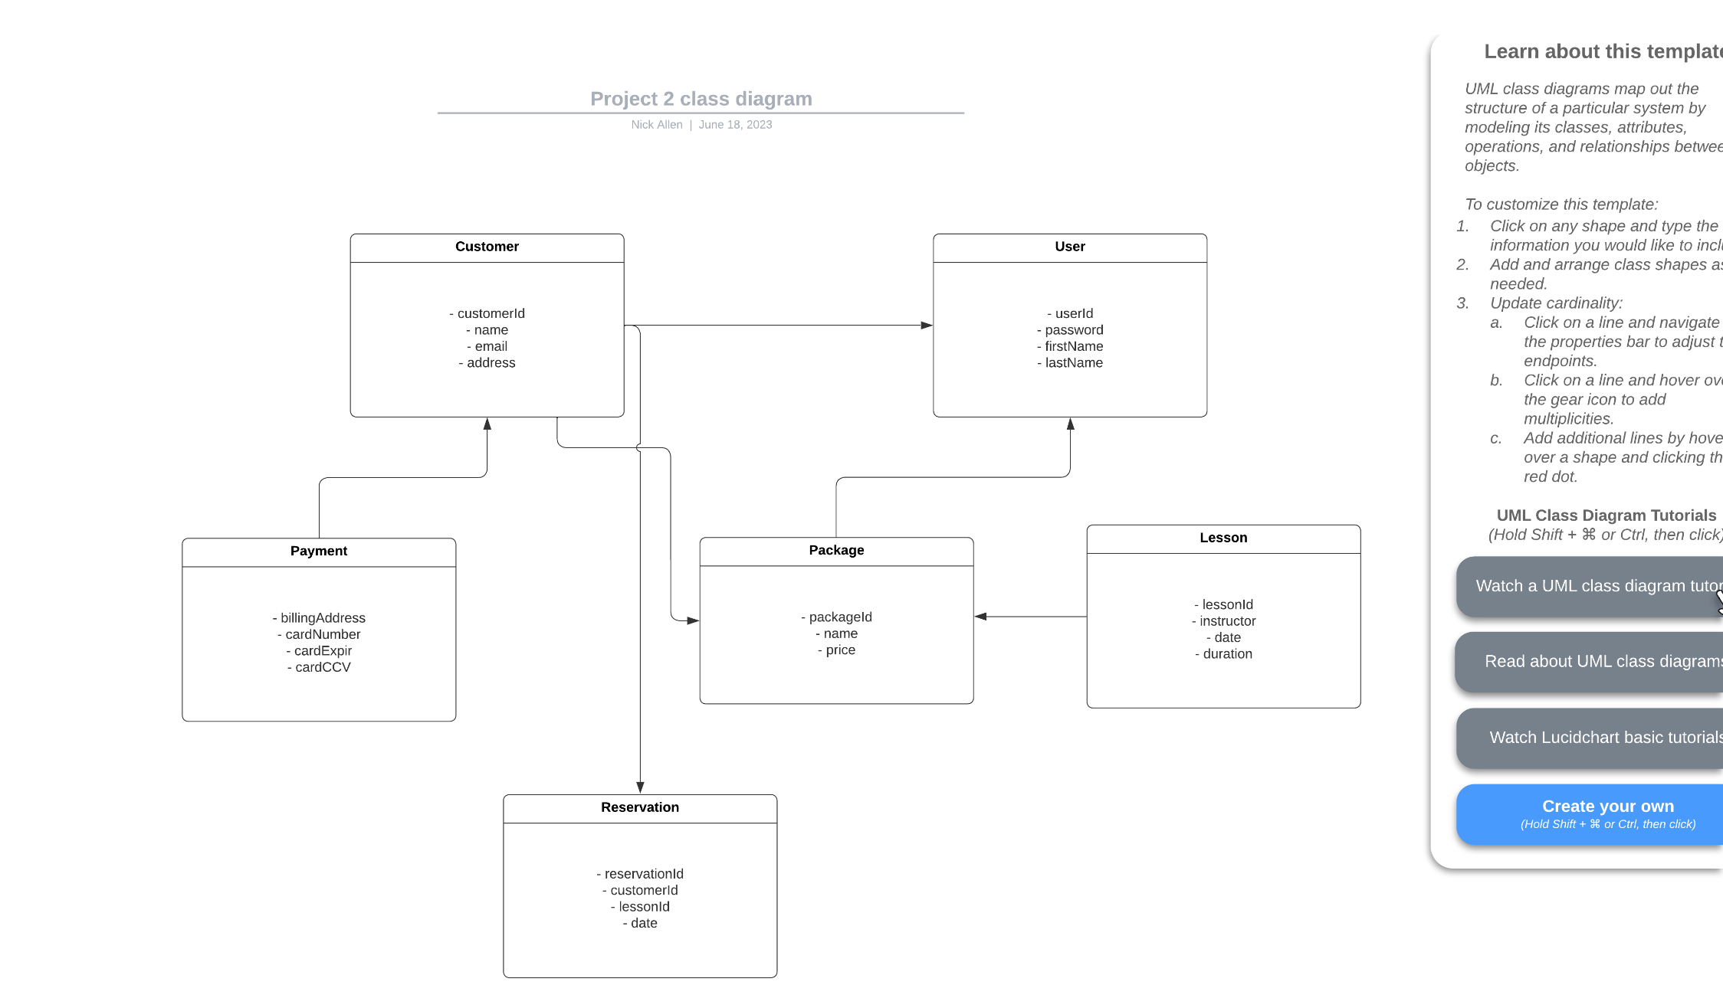

## Technical Requirements

For this system, we need a web-based platform. This will help us be sure that it will be able to handle larger user bases if the system ever needs to scale to a large degree while also giving every customer access, regardless of the device they are using. We will also need a database to store the customer, user, lesson, and progress data. This can either be physical, or through a cloud service, but my recommendation would be through a cloud service, as it will let us scale as needed much easier than using a physical database.